**Group Project – Outputs and Marking-2022**

**MSc. In Applied Software Engineering**

Contents

1. Overall Breakdown 1

2. Project Breakdown (Scaled to 70%) 1

3. Expected Outputs 1

4. Checklist 3

# Overall Breakdown

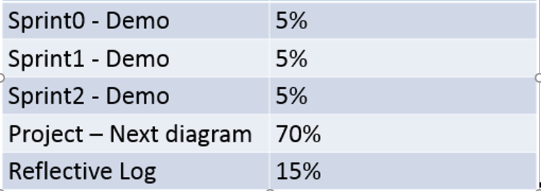

# Project Breakdown (Scaled to 70%)

|  |  |
| --- | --- |
| Weighting | What |
| 35 | Application of Scrum/Teamwork/Methodology/Testing/Environment/CI |
| 45 | Functionality implemented (+PO Feedback on functionality) |
| 20 | Adherence to the given architecture (including code structure and style) |

# Expected Outputs

|  |  |
| --- | --- |
| **What** | **When** |
| Sprint Plan (List of User Stories in Who-What-Why format with Story Point estimates).  Expected Burndown | * Upload to moodle/To Tom Lennon * Monday 24th Jan. 17.00 for Sprint#0 * Monday 14th February 17.00 for Sprint#1 * Monday 7th March 17.00 for Sprint#2 |
| Sprint Goal | * Present as part of demo * Include in final write-up |
| User Story Elaborations for stories committed in current sprint (your sprint backlog)– Elaborate using the Scenario and Given/When/Then -Could use feature files |
| Definition of Done |
| Sprint Plan and Burndown Charts. Present the burndown in terms of hours **and** points(NB).  Note: for points view only burndown when all of a story’s associated tasks are completed. It could look like a stairs (or a cliff). | * Present on demo day – know your velocity and reasons why it might be changing. * Include in write-up |
| Keep a team decision log. | * Submit this as part of your project write up (to AIT). * Have it to hand to answer questions for the demo, but no need to present unless there is something you feel you want to highlight. |
| Design/Architecture Descriptions | * Submit as part of your write up (to AIT). * Keep UML package and class diagrams. Show some (1-3 slides) aspects of ways your architecture is using good design principles e.g. patterns, abstraction, dao etc. in the demo |
| Code Review Checklist – I suggested using slide set from code Review Exercise as a basis for this. | * Submit as part of your write up (to AIT). * Again have to hand for presentation/demo. |
| Daily Stand ups | * You need to have them. Keep them on track. |
| Sprint Retrospective | * Document it and present the main points from it at the next sprint presentation/demo. |
| Test Strategy (per sprint) – write a one page test strategy – focus on the different test levels (unit, integration, system and acceptance). State how much you plan to do at each level and the tools you will use.(Arquillian, Selenium, junit, mockito etc.) | * Present this at sprint demo/presentation. |
| Manual Tests. Document all manual tests (inputs , expected outputs) | * Submit this as part of your write up (to AIT) |
| Test Report (Produce a table showing how many tests you ran at each level, and how many passed). Failing tests should have a bug report | * Present this at sprint demo/presentation |
| User Guide | * Produce a User Guide (per Sprint). For Sprint 1 you can document the “import” because the UI will be changing. For Sprint 2 there is no need to retrofit the UG for Sprint1 stories is for example the UI changed/improved. Print out a sample for the demo. * Submit this as part of your write up (to AIT) |
| Environment -  Bitbucket, Maven, Jenkins, Jira, Sonar and/or PMD | * Everybody should complete a full user story or work on both server and client in sprint#1 and sprint#2. * Present a slide showing what you are doing in terms of CI. How long tests are taking to run etc. For Sprint#1 and Sprint#2 we will look at the CI in more detail. Focus on CI (as opposed to CD). * Make sure you close off your own tasks in Jira. |

# Checklist

|  |
| --- |
| **Checklist for Sprint Presentation/Demo** |
| Sprint Goal |
| User Story Elaborations |
| Definition of Done |
| Burndown Charts |
| Interesting aspects of system architecture/design |
| Previous Sprint Retro – main points |
| Test Strategy |
| Test Report |
| **WORKING SOFTWARE + Feedback from PO – The most important part**  Prepare for the demo and clearly indicate what User Story you are demoing |